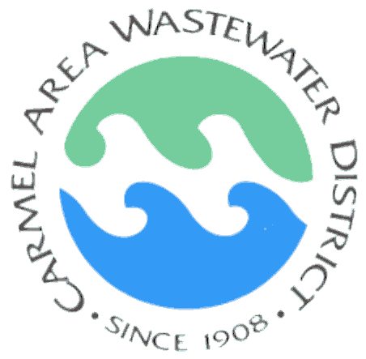
Carmel Area Wastewater District
Waiver of Liability, Assumption of Risk & Indemnity Agreement
Elective/Voluntary Tour Waiver

Waiver: In consideration of being permitted to participate in any way in:
A guided tour of the Carmel Area Wastewater District’s wastewater treatment facility.

Hereinafter called “The Activity”, I, for myself, my heirs, personal representative or assigns, do hereby release, waive, discharge, and covenant not to sue the Carmel Area Wastewater District, its officers, employees, and agents from liability from any and all claims including the negligence of The Directors of the Carmel Area Wastewater District, its officers, employees and agents, resulting in personal injury, accidents, or illnesses (including death) and property loss arising from, but not limited to, participation in The Activity.

Assumption of Risks: Participation in a tour carries with it certain inherent risks that cannot be eliminated regardless of the care taken to avoid injuries. The specific risks vary but the risks range from: 1) minor injuries such as scratches, bruises, and sprains; 2) major injuries such as eye injury or loss of sight, joint or back injuries, heart attacks, and concussions; 3) illness or disease from pathogens contained in wastewater; 4) chemical exposure including burns, inhalation damage; 5) catastrophic injuries including paralysis, drowning and death.

I have read the previous paragraphs and I know, understand, and appreciate these and other risks that are inherent in The Activity. I hereby assert that my participation is voluntary and that I knowingly assume all such risks.

Indemnification and Hold Harmless: I also agree to INDEMNIFY AND HOLD HARMELSS the Directors, its officers, employees and agents of the Carmel Area Wastewater District from any and all claims, actions, suits, procedures, costs, expenses, damages and liabilities, including attorney’s fees brought as a result of my involvement in The Activity and to reimburse them for any such expenses incurred.

Severability: The undersigned further expressly agrees that the foregoing waiver and assumption of risks agreement is intended to be as broad and inclusive as is permitted by the law of the State of California and that if any portion thereof is held invalid, it is agreed that the balance shall, notwithstanding, continue in full legal force and effect.

ACKNOWLEDGEMENT OF UNDERSTANDING: I HAVE READ THIS WAIVER OF LIABILITY, ASSUMPTION OF RISK, AND INDEMNITY AGREEMENT, FULLY UNDERSTAND ITS TERMS, AND UNDERSTAND THAT I AM GIVING UP SUBSTANTIAL RIGHTS, INCLUDING MY RIGHT TO SUE. I ACKNOWLEDGE THAT I AM SIGNING THE AGREEMENT FREELY AND VOLUNTARILY AND INTEND BY MY SIGNATURE TO BE A COMPLETE AND UNCONDITIONAL RELEASE OF ALL LIABILITY TO THE GREATEST EXTENT ALLOWED BY LAW.

____________________________ _________________________ _______________ _____________
Signature of Participant Print Name of Participant Date Age (if Minor)

______________________________________ ________________________________________ ________________
Signature of Parent/Guardian of Participant if Minor Print Name of Parent/Guardian of Participant if Minor Date

